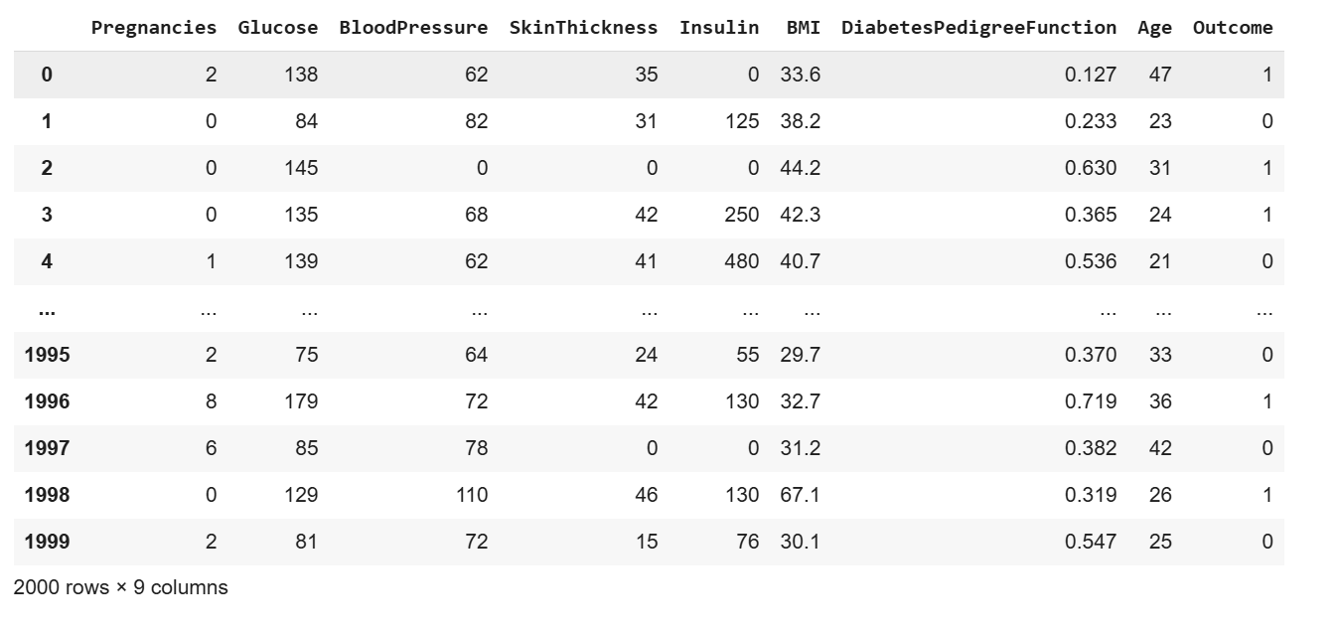

Fig 1 : Data set for the model with shape 2000 X 9

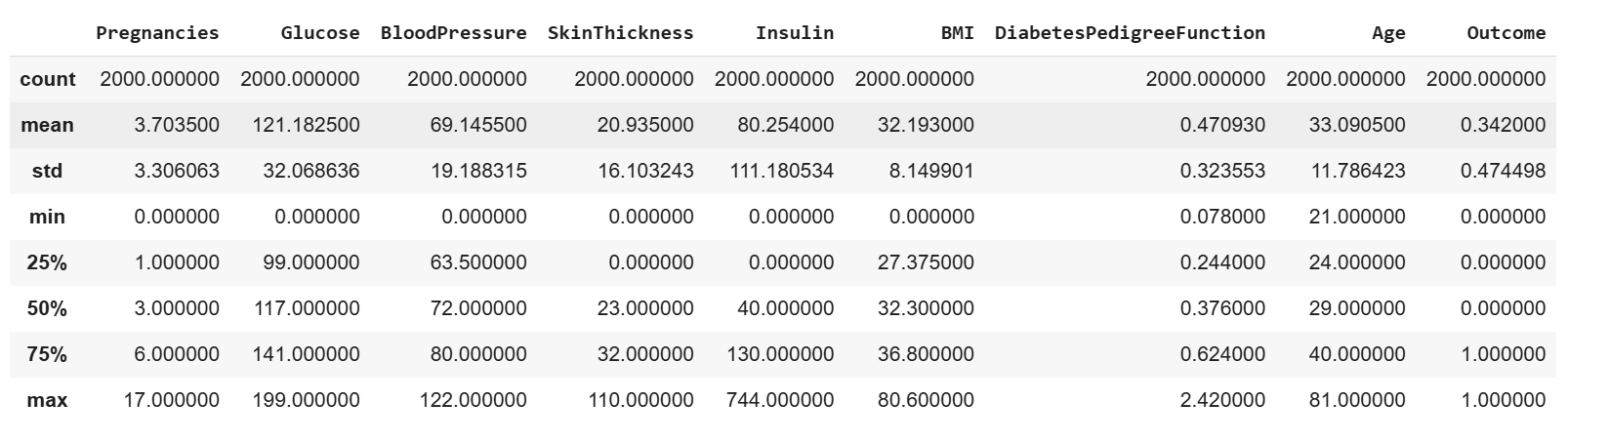

Fig 2 : Statistical measures of the dataset ( count, min, max, std, etc)

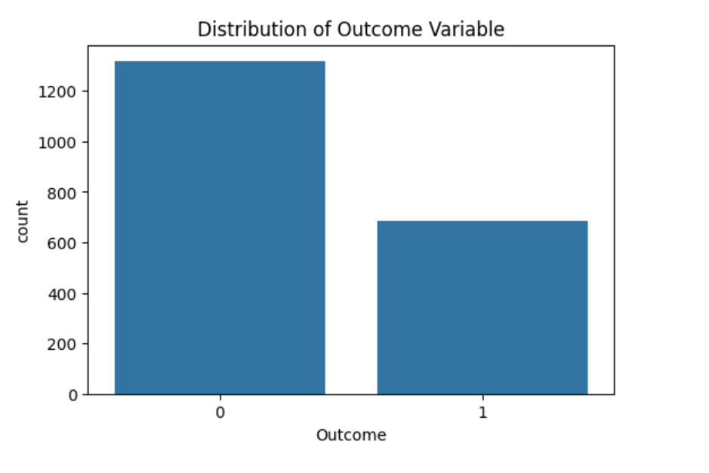

Fig 3 : Distribution of the Outcome Variable

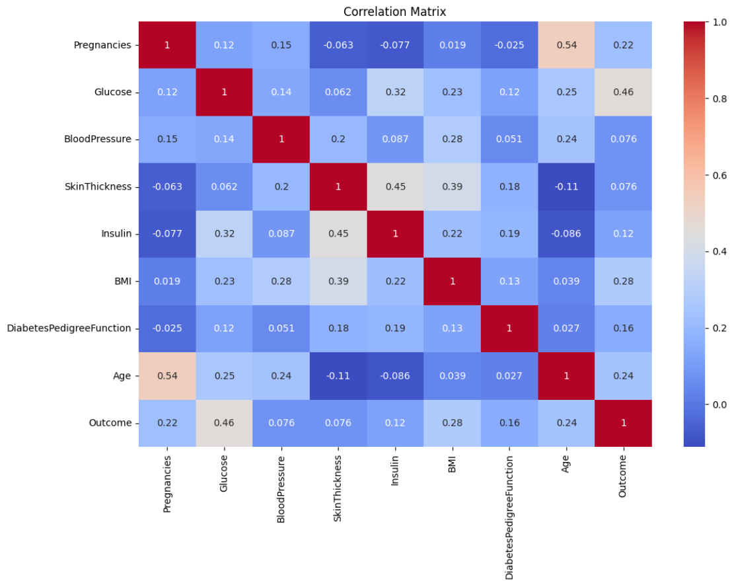

Fig 4 : Correlation matrix of the dataset

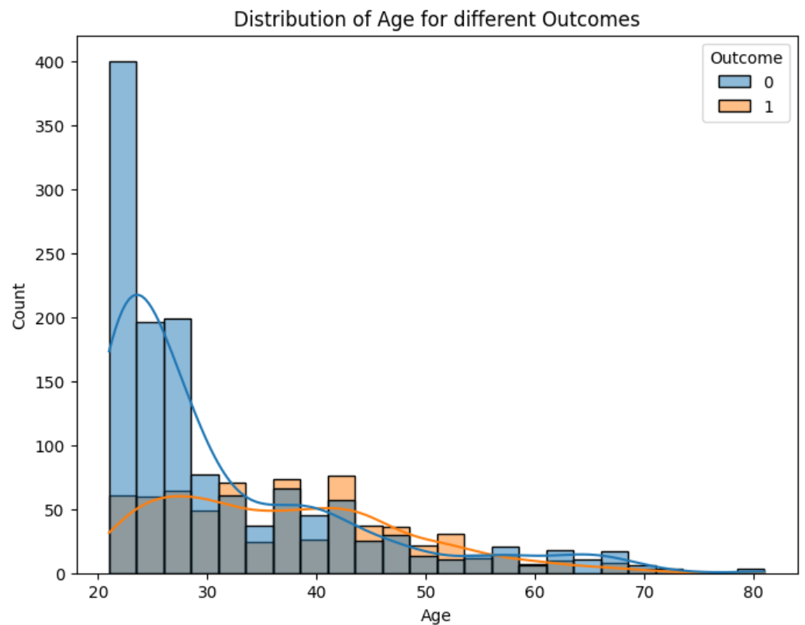

Fig 5 : Distribution of Age for different outcomes

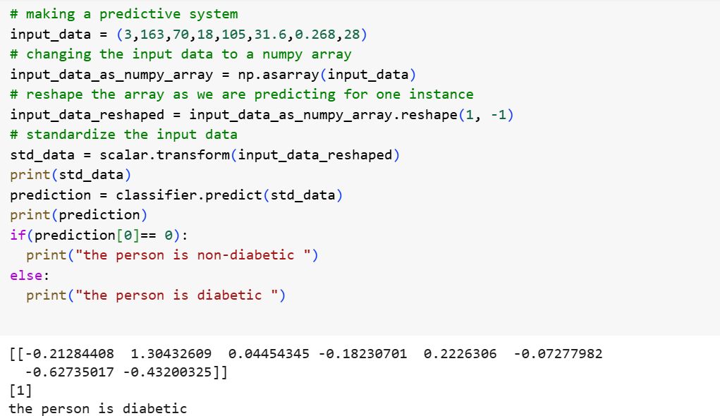

Fig 6 : Input Data and the Final Result